IBN E SINA TIBBIYA COLLEGE & HOSPITAL BEENAPARA AZAMGARH
THE DETAILS OF TEACHING STAFF
S.No | Name of the Teacher and Teacher code | Father’s Name | Date of Birth | UG Qualifation (University & Year) | PG Qualifation (University & Year) | Date wise detals of Experience in chronological order (1* appointment to till date |  |  |  | Registration No. | Date Of initial Joining | Local Residential Address | Permanent Address | Telephone No. & Mobile No. | Photograph
 |  |  |  |  |  | Duration | Designation | Name of the College | Department (Subject)
1 | Mohd Ajmal  UNXX00224 | Itrat Rasool | 15/01/1980 | Jamia Hamdard  2003 | N.A | 01.08.2006 to 30.11.2011 | Lecturer | Ibn-e-sina tibbiya college & hospital | Ain Uzn AAnaf wa Halaque | 10687 | 01.08.2006 | I S T C & H Beenapara Azamgarh | At & Po: Rajapur Sickrour  Distt: Azamgarh | 9450738768 | 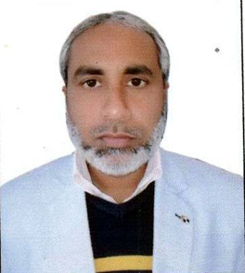
 |  |  |  |  |  | 01.12.2011 to t01.02.2021 | Reader
 |  |  |  |  |  | 02.02.2021 to till date | Professor
 |  |  |  |  |  | 21.03.2015 to till date | Principal & Suptd.
2 | ProF. Hkm. Nasim Ahmad  UNXX00098 | Abdul waheed | 15.05.1969 | B.U.M.S  AMU Aligarh  1995 | N.A | 08.02.1999 to 31.07.2006 | Lecturer | Ibn-e-sina tibbiya college & hospital | Kulliyat | 07959 | 08.02.1999 | I S T C & H Beenapara Azamgarh | Vill: Kourali Post: Saraimeer Distt: Azamgarh | 9838733448 | 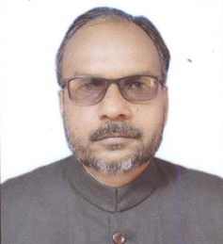
 |  |  |  |  |  | 01.08.2006 to 20.06.2010 | Reader
 |  |  |  |  |  | 21.06.2010 to till date | Professor
3 | Shoeb Ahmad  UNID00005 | Usman Ahmad | 20.06.1962 | B.U.M.S  AMU Aligarh 1991 | M.D (Ilmul Advia)  AMU Aligarh 1996 | 01.07.2004 to 20.06.2010 | Lecturer | Ibn-e-sina tibbiya college & hospital | Ilmul Advia | 7516 | 01.07.2004 | I S T C & H Beenapara Azamgarh | Vill: Teunga Post: Phoolpur Distt: Azamgarh | 9919889655 | 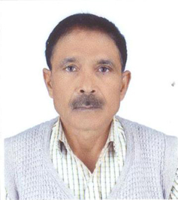
 |  |  |  |  |  | 21.06.2010 to till date | Reader
4 | Mohd Sadique  UNKL00014 | Naseem Ahmad | 15.12.1968 | B.U.M.S  AMU Aligarh 1995 | M.D (Kulliyat) AMU Aligarh  2000 | 01.07.2004 to 20.06.2010 | Lecturer | Ibn-e-sina tibbiya college & hospital | Kulliyat | 07899 | 01.07.2004 | I S T C & H Beenapara Azamgarh | At & Po; Rajapur Sickrour  Distt: Azamgarh | 9648829407 | 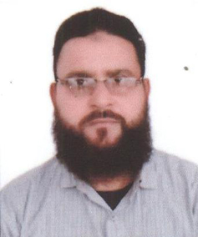
 |  |  |  |  |  | 21.06.2010 to till date | Reader
5 | Tasneem Kausar  UNXX00229 | ANSAR AHMAD | 07.08.1977 | B.U.M.S  AMU Aligarh 2000 | N.A | 01.07.2004 to 20.06.2010 | Lecturer | Ibn-e-sina tibbiya college & hospital | Niswan wa Qabalat | 11789 | 01.07.2004 | I S T C & H Beenapara Azamgarh | At & Po; Rajapur Sickrour  Distt: Azamgarh | 9452369387 | 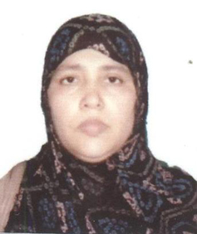
 |  |  |  |  |  | 21.06.2010 to till date | Reader
6 | Salman Ahmad  UNXX00228 | Inamullah Ansari | 06.03.1966 | BUMS  MRT University of HS, Vijayawada 1996 | N..A | 01.07.2004 to 20.06.2010 | Lecturer | Ibn-e-sina tibbiya college & hospital | Tahaffuzi wa Samaji Tib | 10833 | 01.07.2004 | I S T C & H Beenapara Azamgarh | Mohall:  76 Asifganj Post: Sadar Distt: Azamgarh | 9451356668 | 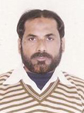
 |  |  |  |  |  | 21.06.2010 to till date | Reader
7 | Abu Asim  UNXX00226 | Ainul Haque | 17.06.1964 | B.U.M.S University of Pune 1993 | N.A | 01.07.2004 to 20.06.2010 | Lecturer | Ibn-e-sina tibbiya college & hospital | Ain Uzn AAnaf wa Halaque | 7747 | 01.07.2004 | I S T C & H Beenapara Azamgarh | At & Post Sabrahad Imampur Disst Jaunpur | 9554246341 | 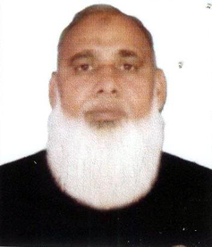
 |  |  |  |  |  | 21.06.2010 to till date | Reader
Cont on page 2
(2)

8 | Ahmad Tarique Nadeem Khan  UNXX00097 | Mohammad Zafar Khan | 15.07.1978 | B.U.M.S  CSJM University Kanpur  2001 | N.A | 01.07.2004 to 20.06.2010 | Lecturer | Ibn-e-sina tibbiya college & hospital | Mahiyatul Amraz | 10086 | 01.07.2004 | I S T C & H Beenapara Azamgarh | ALI AUSAT COLONY POST: SIDHARI Distt; Azamgarh | 9450824955 | 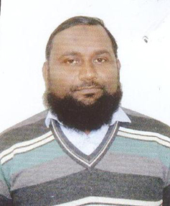
 |  |  |  |  |  | 21.06.2010 to till date | Reader
9 | Mohammad Zakariya  UNXX00225 | Vakeel Ahmad | 13.05.1973 | B.U.M.S  CSJM University 2001 | N.A | 01.08.2006 to 30.11.2011 | Lecturer | Ibn-e-sina tibbiya college & hospital | Tahaffuzi wa Samaji Tib | 11004 | 01.08.2006 | I S T C & H Beenapara Azamgarh | AT & POST : KONI KONDHA AZAMGARH | 8005441872 | 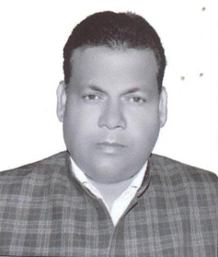
 |  |  |  |  |  | 01.12.2011 to till date | Reader
10 | Abul Quais  UNXX00268 | Ilyas Ahmad | 17.01.1976 | B.U.M.S  AMU Aligarh 2006 | N.A | 01.08.2006 to 30.11.2011 | Lecturer | Ibn-e-sina tibbiya college & hospital | Amraz-e-Jild wa Tazeeniyat | 11704 | 01.08.2006 | I S T C & H Beenapara Azamgarh | Vill: Chamawan, Po: Phoolpur Distt: Azamgarh | 9450827427 | 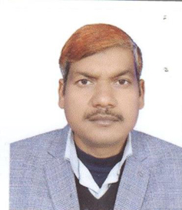
 |  |  |  |  |  | 01.12.2011 to till date | Reader
11 | Hkm. Jamsheed Alam  UNXX00227 | Faiyaz Ahmad | 28.02.1971 | JAMIA HAMDARD 1997 | N.A | 01.07.2004 to 30.09.2009 | Lecturer | Ibn-e-sina tibbiya college & hospital | Jarahat | 10860 | 01.07.2004 | I S T C & H Beenapara Azamgarh | AT: ASARA POST: NANDAW DISTT; AZAMGARH | 9958467012 | 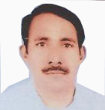
 |  |  |  |  |  | 21.06.2010 to 31.08.2015 | Reader
 |  |  |  |  |  | 02.08.2017 to till date | Reader
12 | Faheem Raza Khan  UNXX00223 | Laique Raza Khan | 01.07.1979 | B.U.M.S  CSJM University Kanpur  2005 | N.A | 01.10.2009 to 30.11.2014 | Lecturer | Ibn-e-sina tibbiya college & hospital | Tahaffuzi wa Samaji Tib | 12259 | 01.10.2009 | I S T C & H Beenapara Azamgarh | ALI AUSAT COLONY POST: SADAR DISTT AZAMGARH | 8090479610 | 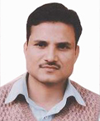
 |  |  |  |  |  | 01.12.2014 to 22.08.2015 | Reader
 |  |  |  |  |  | 02.08.2017 to till date | Reader
13 | Parvez Kamal Durrani  UNXX00222 | Irshad Ahmad | 05.03.1970 | B.U.M.S  University of Bihar  2000 | N.A | 01.10.2009 to 30.11.2014 | Lecturer | Ibn-e-sina tibbiya college & hospital | Munafiul Aza AZA | 09091 | 01.10.2009 | I S T C & H Beenapara Azamgarh | MOHALLA HUSAINABAD DISTT AZAMGARH | 9452479811 | 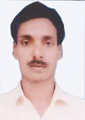
 |  |  |  |  |  | 01.12.2014 to 22.08.2015 | Reader
 |  |  |  |  |  | 01.08.2017 to Till Date | Reader
14 | Sharfuddin  UNXX00221 | Abu Bakar | 06.03.1959 | B.U.M.S  AMU Aligarh 1981 | N.A | 01.10.2009 to 30.11.2014 | Lecturer | Ibn-e-sina tibbiya college & hospital | Mahiyatul Amraz | 5567 | 01.10.2009 | I S T C & H Beenapara Azamgarh | AT & PSOT: SHAHGANJ DISTT: JAUNPUR | 9415315155 | 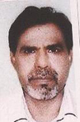
 |  |  |  |  |  | 01.12.2014 to 15.08.2015 | Reader
 |  |  |  |  |  | 02.08.2017 to Till Date | Reader

Cont on page 3

(3)

15 | Irfan Ahmad  UNXX00219 | Mohd Haneef | 28.02.1978 | B.U.M.S  CSJM University Kanpur  2004 | N.A | 01.10.2009 to 30.11.2014 | Lecturer | Ibn-e-sina tibbiya college & hospital | Moalijat | 11693 | 01.10.2009 | I S T C & H Beenapara Azamgarh | MOHALLA FARHABAD POST NIZAMABAD DISTT; AZAMGARH | 9044735620 | 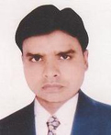
 |  |  |  |  |  | 01.12.2014 to 22.08.2015 | Reader
 |  |  |  |  |  | 01.08.2017 to Till Date | Reader
16 | Hkm. Nadeem Ahmad  UNXX00216 | Ali Sajjad | 01.01.1974 | B.U.M.S  AMU ALIGARH  2002 | N.A | 01.08.2012 to 03.01.2020 | Lecturer | Ibn-e-sina tibbiya college & hospital | Ilaj Bit Tadbeer | 10057 | 01.08.2012 | I S T C & H Beenapara Azamgarh | AT & POST RAJAPUR SIKRAOU DISTT: aZAMGARH | 8009082218 | 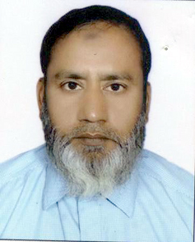
 |  |  |  |  |  | 04.01.2020 to till date | Reader
17 | nASEEM aKHTER | SHAMIM AHMAD | 03.05.1974 | B.U.M.S  CSJM University Kanpur  2001 | N.A | 01.10.2009 to 30.11.2014 | Lecturer | Ibn-e-sina tibbiya college & hospital | Tashreehul Badan | 10142 | 01.10.2009 | I S T C & H Beenapara Azamgarh | Vill: Teunga Post: Phoolpur Distt: Azamgarh | 9415654581 | 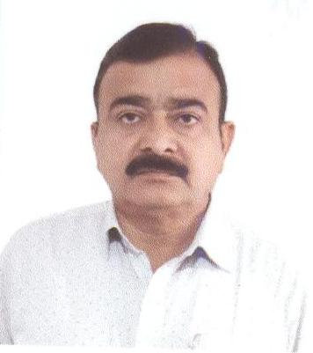
 |  |  |  |  |  | 01.12.2014 to 31.12.2015 | Reader
 |  |  |  |  |  | 01.12.2020 to till date | Reader
18 | Tabiba Aisha Atiqurrahman  UNXX00215 | Atiqur Rahman Khan | 19.07.1982 | Maharast RA UNIVERSITY OF  H. SINC. NASHIK  2004 | N.A | 01.08.2012 to 01.02.2021 | Lecturer | Ibn-e-sina tibbiya college & hospital | Ilmul Atfal | 13749 | 01-08-2012 | I S T C & H Beenapara Azamgarh | AT & POST RAJAPUR SIKRAOU DISTT: aZAMGARH | 9198756712 | 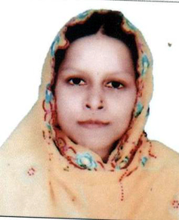
 |  |  |  |  |  | 02.02.2021 to till date | Reader
19 | Tabiba Zeba Tasneem  UNXX00214 | Mohd Fareed | 01.08.1982 | B.U.M.S  CSJM University Kanpur  2006 | N.A | 01.08.2012 to 08.08.2015 | Lecturer | Ibn-e-sina tibbiya college & hospital | Niswan wa Qabalat | 13061 | 01.08.2012 | I S T C & H Beenapara Azamgarh | MAT ANWAK POST: SIRSAL DISTT:AZAMGARH | 7080449054 | 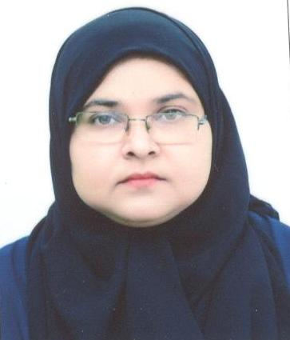
 |  |  |  |  |  | 01.08.2017 to 01.02.2021 | Lecturer
 |  |  |  |  |  | 02.02.2021 to till date | Reader
20 | Hkm. Mohd Tahir  UNXX00213 | Mohd Taiyyab | 01.01.1980 | B.U.M.S  CSJM University Kanpur  2005 | N.A | 01.08.2012 to 08.08.2015 | Lecturer | Ibn-e-sina tibbiya college & hospital | Mahiyatul Amraz | 12165 | 01.08.2012 | I S T C & H Beenapara Azamgarh | AT; BARAI PUR POST: BAKUCHI DISTT: AZAMGARH | 7785830293 | 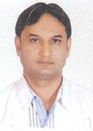
 |  |  |  |  |  | 01.08.2017 to 01.02.2021 | Lecturer
 |  |  |  |  |  | 02.02.2021 to till date | Reader
21 | Hkm. Nadeem Ahmad Khan  UNXX00217 | Abdullah Khan | 10.03.1982 | UNIVERSTY OF CALCUTA 2005 | N.A | 21.06.2010 to 22.08.2015 | Lecturer | Ibn-e-sina tibbiya college & hospital | Amraz-e-Jild wa Tazeeniyat | 13373 | 21.06.2010 | I S T C & H Beenapara Azamgarh | AT & POST : SHAHGANJ DIST: JAUNPUR | 7388169400 | 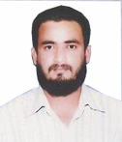
 |  |  |  |  |  | 02.08.2017 to 01.02.2021 | Lecturer
 |  |  |  |  |  | 02.02.2021 to till date | Reader

Cont on page 4
(4)

22 | Hkm. Shah Alam  UNXX00212 | Mr. Ajaz Ahmad | 20.11.1978 | BUMS AMU ALIGARH 2003 | N.A | 01.08.2012 to 08.08.2015 | Lecturer | Ibn-e-sina tibbiya college & hospital | Munafiul Aza | 11931 | 01.08.2012 | I S T C & H Beenapara Azamgarh | AT & PSOT MUNDIYAT DISTT: AZAMGRH | 9455488723 | 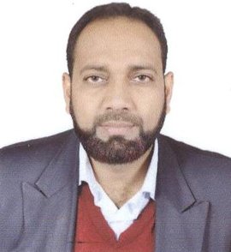
 |  |  |  |  |  | 01.09.2017 to 01.02.2021 | Lecturer
 |  |  |  |  |  | 02.02.2021 to till date | Reader
23 | Hkm. Serajuddin  UNJH00010 | Mr. Mohd Ali | 25.05.1987 | B.U.M.S AMU ALIGARHG 2013 | M.S (Ilmul Jarahat)  AMU ALIGARHG  2017 | 01.01.2018 | Lecturer | Ibn-e-sina tibbiya college & hospital | Jarahat | 16722 | 01.01.2018 | I S T C & H Beenapara Azamgarh | VILL: CHEUNATAHA POST; NASIRGANJ DISTT: SIDDHARTHNAGAR | 9456201554 | 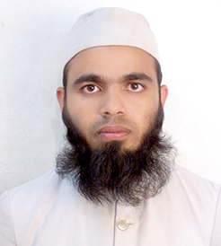
24 | Hkm. Parwej Ahmad  UNID00026 | Mr. Salamatullah | 01.06.1983 | B.U.M.S JAMIA HAMDARD 2007 | M.D (Ilmul Advia)  R G U H S bANGALOR  2016 | 08.01.2018 | Lecturer | Ibn-e-sina tibbiya college & hospital | Ilmul Advia | 13281 | 08.01.2018 | I S T C & H Beenapara Azamgarh | VILL; SEMRA POST : ITWA DISTT: SIDDARTHNAGAR | 8147375283 | 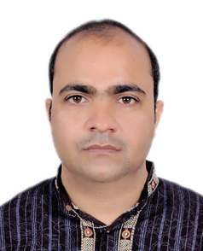
25 | Hkm. Mohd Faisal  UNJH00006 | abrar ahmad | 02.08.1987 | B.U.M.S JAMIA HAMDARD 2013 | M.S (Ilmul Jarahat)  R G U H S bANGALOR  2019 | 19.01.2019 | Lecturer | Ibn-e-sina tibbiya college & hospital | Jarahat | 17223 | 19.01.2019 | I S T C & H Beenapara Azamgarh | Vill & Post: Towa Distt: Azamgarh | 9686398398 | 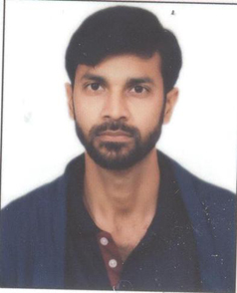
26 | hkm zafar javed khan  UNID00002 | javed ahmad khan | 04.06.1985 | B.U.M.S AMU Aligarh 2011 | m.d (ilmul advia)  AMU Aligarh 2017 | 05/11/2019 | Lecturer | Ibn-e-sina tibbiya college & hospital | Ilmul Advia | 14961 | 05.11.2019 | I S T C & H Beenapara Azamgarh | Vill & Post: Mohammadpur Distt: azamgarh | 8791655865 | 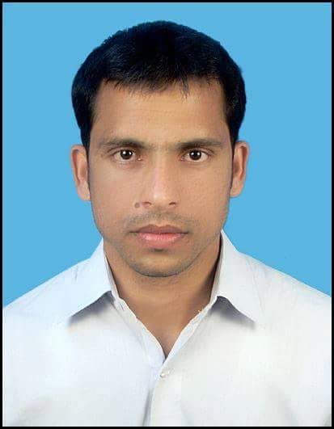
27 | HKm. mohammad asan  unmj00212 | mohammad khalid farooqui | 24.12.1990 | B.U.M.S AMU Aligarh 2015 | m.d (Moalijat) AMU Aligarh 2019 | 19.012.2019 | Lecturer | Ibn-e-sina tibbiya college & hospital | Moalijat | 17927 | 19.02.2019 | I S T C & H Beenapara Azamgarh | Vill & Post: Neori Distt: Ambedkar nagar | 8630911168 | 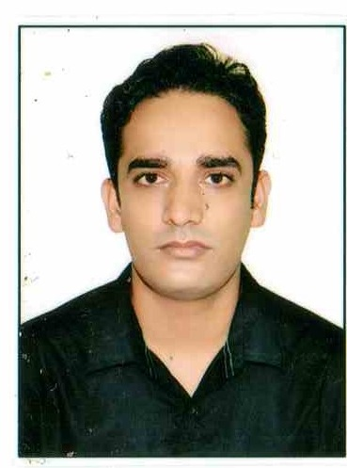
28 | hkm. mirza faiz beg  unkl00066 | mirza irfan beg | 01.02.1989 | B.U.M.S JAMIA HAMDARD 2013 | M.d (kulliyuat)  R G U H S bANGALOR  2019 | 02.01.2020 | Lecturer | Ibn-e-sina tibbiya college & hospital | Munafiul Aza | 17222 | 19.01.2020 | I S T C & H Beenapara Azamgarh | Vill: M Patti Post: Semari Distt: Azamgarh | 9958368858 | 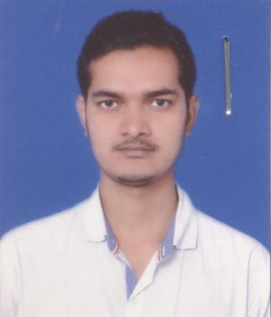
29 | hkm. mirza BELAL BEG  UNID00168 | mirza SULTAN BEG | 05.09.1989 | B.U.M.S AMU Aligarh 2015 | M.d (ILMUL ADVIA)  K N R U H S TELANGANA  2020 | 10.12.2020 | Lecturer | Ibn-e-sina tibbiya college & hospital | Ilmul Sadila | 17896 | 10.12.2020 | I S T C & H Beenapara Azamgarh | Vill: Abdiha Post: Beenapara Distt: Azamgarh | 7417840003 | 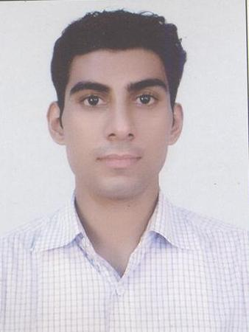

Cont on page 5
(5)

30 | tabiba habiba suhail  UNNQ00114 | auhail ahmad | 15.07.1991 | B.U.M.S AMU Aligarh 2015 | M.s  (il qabalat wa a niswan)  R G U H S bANGALOR  2020 | 10.12.2020 | Lecturer | Ibn-e-sina tibbiya college & hospital | Ilmul Atfal | 17898 | 10.12.2020 | I S T C & H Beenapara Azamgarh | Vill: Abdiha Post: Beenapara Distt: Azamgarh | 8272876066 | 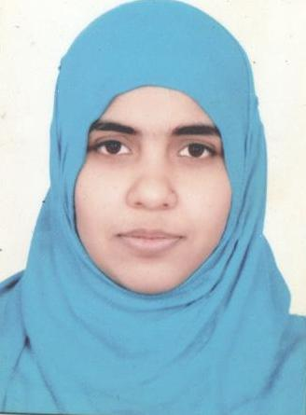
31. | hkm mohd rashid  UNID00017 | zainul abdin | 29.08.1987 | B.U.M.S AMU Aligarh 2015 | M.d  (ilah bit tadbeer)  R G U H S bANGALOR  2020 | 10.12.2020 | Lecturer | Ibn-e-sina tibbiya college & hospital | Ilaj Bit Tadbeer | 17919 | 10.12.2020 | I S T C & H Beenapara Azamgarh | Vill: Bholepur Post: Hanswar Distt: Ambedkar Nagar | 7217547126 | 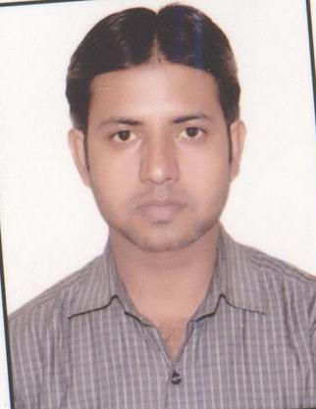
32 | Tabiba Nazreen Fatma  UNMJ00351 | Mohd Ilyas | 02.06.1993 | B.U.M.S JAMIA HAMDARD 2015 | M.d  (Moalijat)  R G U H S bANGALOR  2020 | 11.01.2021 | Lecturer | Ibn-e-sina tibbiya college & hospital | Moalijat | 18293 | 11.01.2021 | I S T C & H Beenapara Azamgarh | 15/116 Paltan Bazar Distt: Pratapgarh | 9873772366 | 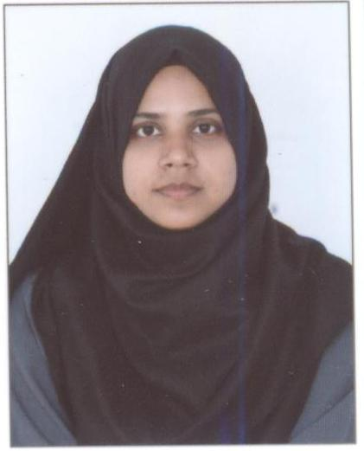
33 | MOHAMMAD SHAHABUDDIN | SHABBIR AHMED | 01.07.1987 | B.U.M.S JAMIA HAMDARD 2009 | M.d  (iLMUL SAIDLA)  DELHI UNIVERSITY  2015 | 17.01.2022 | Lecturer | Ibn-e-sina tibbiya college & hospital | Ilmul Saidla | 14733 | 17.01.2023 | I S T C & H Beenapara Azamgarh | Vill Bhikharipur post: bhopaura Distt: Mau | 9716966737 | 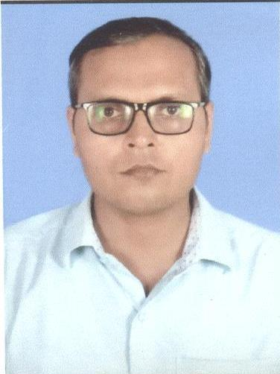
34 | Dr. Abu Obaid | Mohd Anas | 14.11.1962 | B.A . JAMIA MILLIA NEW DELHI 1986 | M.A. & PhD. JAMIA MILLIA NEW DELHI 1989 &1994 | 15.07.1995 | Lecturer | Ibn-e-sina tibbiya college & hospital | Kulliyat | N.A | 17.07.1995 | I S T C & H Beenapara Azamgarh | AT : MANJEERPATTI POST: BEENAPARA AZAMGARH | 72756707671 | 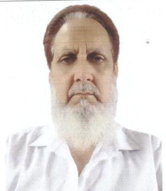
35 | Miss. Ayesha Jafar | Jafar Taiyar Khan | 28.12.1992 | BA  VBSP UNIVERSITY JANPUR 2010 | M.A  VBSP UNIVERSITY JANPUR  2012 | 03.08.2017 | Lecturer | Ibn-e-sina tibbiya college & hospital | Kulliyat | N.A | 03-08.2017 | I S T C & H Beenapara Azamgarh | MOHALLA BAZBAHADUR POST SADAR DISTT AZMAGRAH | 9415838523 | 

