Details of Teaching Faculty
S.No | Name of the Teacher and Teacher code | Father’s Name | Date of Birth | UG Qualifation (University & Year) | PG Qualifation (University & Year) | Date wise detals of Experience in chronological order (1* appointment to till date |  |  |  | Local Residential Address | Permanent Address | Telephone No. & Mobile No. | Photograph
 |  |  |  |  |  | Duration | Designation | Name of the College | Department (Subject)
1 | Mohd Ajmal  UNXX00224 | Itrat Rasool | 15/01/1980 | Jamia Hamdard  2003 | N.A | 01.08.2006 to 30.11.2011 | Lecturer | Ibn-e-sina tibbiya college & hospital | Ain Uzn AAnaf wa Halaque | I S T C & H Beenapara Azamgarh | At & Po: Rajapur Sickrour  Distt: Azamgarh | 9450738768 | 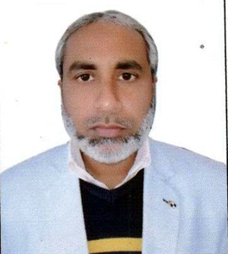
 |  |  |  |  |  | 01.12.2011 to t01.02.2021 | Reader
 |  |  |  |  |  | 02.02.2021 to till date | Professor
 |  |  |  |  |  | 21.03.2015 to till date | Principal & Suptd.
2 | ProF. Hkm. Nasim Ahmad  UNXX00098 | Abdul waheed | 15.05.1969 | B.U.M.S  AMU Aligarh  1995 | N.A | 08.02.1999 to 31.07.2006 | Lecturer | Ibn-e-sina tibbiya college & hospital | Kulliyat | I S T C & H Beenapara Azamgarh | Vill: Kourali Post: Saraimeer Distt: Azamgarh | 9838733448 | 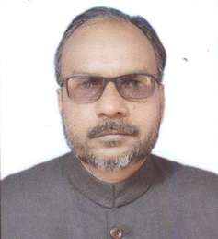
 |  |  |  |  |  | 01.08.2006 to 20.06.2010 | Reader
 |  |  |  |  |  | 21.06.2010 to till date | Professor
3 | Mohd Sadique  UNKL00014 | Naseem Ahmad | 15.12.1968 | B.U.M.S  AMU Aligarh 1995 | M.D (Kulliyat) AMU Aligarh  2000 | 01.07.2004 to 20.06.2010 | Lecturer | Ibn-e-sina tibbiya college & hospital | Kulliyat | I S T C & H Beenapara Azamgarh | At & Po; Rajapur Sickrour  Distt: Azamgarh | 9648829407 | 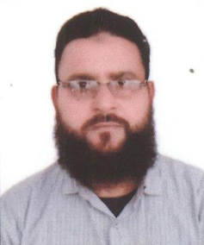
 |  |  |  |  |  | 21.06.2010 to 04.04.2022 | Reader
 |  |  |  |  |  | 05.04.2022 to Till Date | Reader | Ibn-e-sina tibbiya college & hospital | Tashreehul Badan
4 | Tasneem Kausar  UNXX00229 | ANSAR AHMAD | 07.08.1977 | B.U.M.S  AMU Aligarh 2000 | N.A | 01.07.2004 to 20.06.2010 | Lecturer | Ibn-e-sina tibbiya college & hospital | Niswan wa Qabalat | I S T C & H Beenapara Azamgarh | At & Po; Rajapur Sickrour  Distt: Azamgarh | 9452369387 | 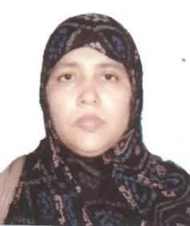
 |  |  |  |  |  | 21.06.2010 to till date | Reader
5 | Salman Ahmad  UNXX00228 | Inamullah Ansari | 06.03.1966 | BUMS  MRT University of HS, Vijayawada 1996 | N..A | 01.07.2004 to 20.06.2010 | Lecturer | Ibn-e-sina tibbiya college & hospital | Tahaffuzi wa Samaji Tib | I S T C & H Beenapara Azamgarh | Mohall:  76 Asifganj Post: Sadar Distt: Azamgarh | 9451356668 | 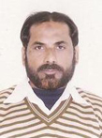
 |  |  |  |  |  | 21.06.2010 to till date | Reader
6 | Abu Asim  UNXX00226 | Ainul Haque | 17.06.1964 | B.U.M.S University of Pune 1993 | N.A | 01.07.2004 to 20.06.2010 | Lecturer | Ibn-e-sina tibbiya college & hospital | Ain Uzn AAnaf wa Halaque | I S T C & H Beenapara Azamgarh | At & Post Sabrahad Imampur Disst Jaunpur | 9554246341 | 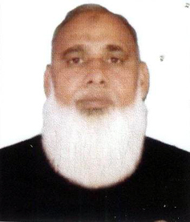
 |  |  |  |  |  | 21.06.2010 to till date | Reader
7 | Ahmad Tarique Nadeem Khan  UNXX00097 | Mohammad Zafar Khan | 15.07.1978 | B.U.M.S  CSJM University Kanpur  2001 | N.A | 01.07.2004 to 20.06.2010 | Lecturer | Ibn-e-sina tibbiya college & hospital | Mahiyatul Amraz | I S T C & H Beenapara Azamgarh | ALI AUSAT COLONY POST: SIDHARI Distt; Azamgarh | 9451832349 | 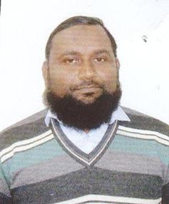
 |  |  |  |  |  | 21.06.2010 to till date | Reader

Cont on page 2
(2)

S.No | Name of the Teacher and Teacher code | Father’s Name | Date of Birth | UG Qualifation (University & Year) | PG Qualifation (University & Year) | Date wise detals of Experience in chronological order (1* appointment to till date |  |  |  | Local Residential Address | Permanent Address | Telephone No. & Mobile No. | Photograph
 |  |  |  |  |  | Duration | Designation | Name of the College | Department (Subject)
8 | Mohammad Zakariya  UNXX00225 | Vakeel Ahmad | 13.05.1973 | B.U.M.S  CSJM University Kanpur  2001 | N.A | 01.08.2006 to 30.11.2011 | Lecturer | Ibn-e-sina tibbiya college & hospital | Tahaffuzi wa Samaji Tib | I S T C & H Beenapara Azamgarh | AT & POST : KONI KONDHA AZAMGARH | 8005441872 | 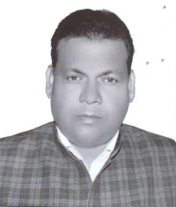
 |  |  |  |  |  | 01.12.2011 to till date | Reader
9 | Abul Quais  UNXX00268 | Ilyas Ahmad | 17.01.1976 | B.U.M.S  AMU Aligarh 2006 | N.A | 01.08.2006 to 30.11.2011 | Lecturer | Ibn-e-sina tibbiya college & hospital | Amraz-e-Jild wa Tazeeniyat | I S T C & H Beenapara Azamgarh | Vill: Chamawan, Po: Phoolpur Distt: Azamgarh | 9450827427 | 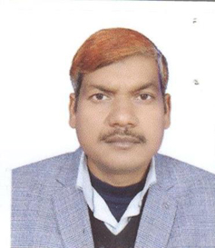
 |  |  |  |  |  | 01.12.2011 to till date | Reader
10 | Hkm. Jamsheed Alam  UNXX00227 | Faiyaz Ahmad | 28.02.1971 | JAMIA HAMDARD 1997 | N.A | 01.07.2004 to 30.09.2009 | Lecturer | Ibn-e-sina tibbiya college & hospital | Jarahat | I S T C & H Beenapara Azamgarh | AT: ASARA POST: NANDAW DISTT; AZAMGARH | 9958467012 | 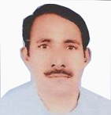
 |  |  |  |  |  | 21.06.2010 to 31.08.2015 | Reader
 |  |  |  |  |  | 02.08.2017 to till date | Reader
11 | Faheem Raza Khan  UNXX00223 | Laique Raza Khan | 01.07.1979 | B.U.M.S  CSJM University Kanpur  2005 | N.A | 01.10.2009 to 30.11.2014 | Lecturer | Ibn-e-sina tibbiya college & hospital | Tahaffuzi wa Samaji Tib | I S T C & H Beenapara Azamgarh | ALI AUSAT COLONY POST: SADAR DISTT AZAMGARH | 9450185075 | 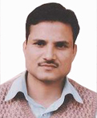
 |  |  |  |  |  | 01.12.2014 to 22.08.2015 | Reader
 |  |  |  |  |  | 02.08.2017 to till date | Reader
12 | Parvez Kamal Durrani  UNXX00222 | Irshad Ahmad | 05.03.1970 | B.U.M.S  University of Bihar  2000 | N.A | 01.10.2009 to 30.11.2014 | Lecturer | Ibn-e-sina tibbiya college & hospital | Munafiul Aza AZA | I S T C & H Beenapara Azamgarh | MOHALLA HUSAINABAD DISTT AZAMGARH | 9452479811 | 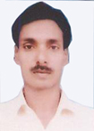
 |  |  |  |  |  | 01.12.2014 to 22.08.2015 | Reader
 |  |  |  |  |  | 01.08.2017 to Till Date | Reader
13 | Irfan Ahmad  UNXX00219 | Mohd Haneef | 28.02.1978 | B.U.M.S  CSJM University Kanpur  2004 | N.A | 01.10.2009 to 30.11.2014 | Lecturer | Ibn-e-sina tibbiya college & hospital | Moalijat | I S T C & H Beenapara Azamgarh | MOHALLA FARHABAD POST NIZAMABAD DISTT; AZAMGARH | 9044735620 | 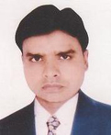
 |  |  |  |  |  | 01.12.2014 to 22.08.2015 | Reader
 |  |  |  |  |  | 01.08.2017 to Till Date | Reader
14 | Hkm. Nadeem Ahmad  UNXX00216 | Ali Sajjad | 01.01.1974 | B.U.M.S  AMU ALIGARH  2002 | N.A | 01.08.2012 to 03.01.2020 | Lecturer | Ibn-e-sina tibbiya college & hospital | Ilaj Bit Tadbeer | I S T C & H Beenapara Azamgarh | AT & POST RAJAPUR SIKRAOU DISTT: aZAMGARH | 8009082218 | 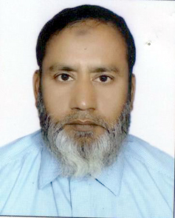
 |  |  |  |  |  | 04.01.2020 to till date | Reader

Cont. on page 3
(3)

S.No | Name of the Teacher and Teacher code | Father’s Name | Date of Birth | UG Qualifation (University & Year) | PG Qualifation (University & Year) | Date wise detals of Experience in chronological order (1* appointment to till date |  |  |  | Local Residential Address | Permanent Address | Telephone No. & Mobile No. | Photograph
 |  |  |  |  |  | Duration | Designation | Name of the College | Department (Subject)
15 | nASEEM aKHTER | SHAMIM AHMAD | 03.05.1974 | B.U.M.S  CSJM University Kanpur  2001 | N.A | 01.10.2009 to 30.11.2014 | Lecturer | Ibn-e-sina tibbiya college & hospital | Tashreehul Badan | I S T C & H Beenapara Azamgarh | Vill: Teunga Post: Phoolpur Distt: Azamgarh | 9415654581 | 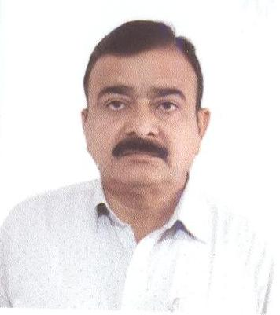
 |  |  |  |  |  | 01.12.2014 to 31.12.2015 | Reader
 |  |  |  |  |  | 01.12.2020 to till date | Reader
16 | Tabiba Aisha Atiqurrahman  UNXX00215 | Atiqur Rahman Khan | 19.07.1982 | Maharast RA UNIVERSITY OF H. SINC. NASHIK  2004 | N.A | 01.08.2012 to 01.02.2021 | Lecturer | Ibn-e-sina tibbiya college & hospital | Ilmul Atfal | I S T C & H Beenapara Azamgarh | AT & POST RAJAPUR SIKRAOU DISTT: aZAMGARH | 9198756712 | 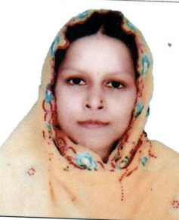
 |  |  |  |  |  | 02.02.2021 to till date | Reader
17 | Tabiba Zeba Tasneem  UNXX00214 | Mohd Fareed | 01.08.1982 | B.U.M.S  CSJM University Kanpur  2006 | N.A | 01.08.2012 to 08.08.2015 | Lecturer | Ibn-e-sina tibbiya college & hospital | Niswan wa Qabalat | I S T C & H Beenapara Azamgarh | AT: ANWAK POST: SIRSAL DISTT:AZAMGARH | 7080449054 | 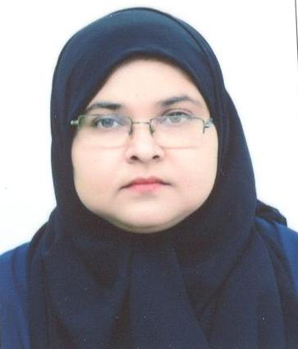
 |  |  |  |  |  | 01.08.2017 to 01.02.2021 | Lecturer
 |  |  |  |  |  | 02.02.2021 to till date | Reader
18 | Hkm. Mohd Tahir  UNXX00213 | Mohd Taiyyab | 01.01.1980 | B.U.M.S  CSJM University Kanpur  2005 | N.A | 01.08.2012 to 08.08.2015 | Lecturer | Ibn-e-sina tibbiya college & hospital | Mahiyatul Amraz | I S T C & H Beenapara Azamgarh | AT; BARAI PUR POST: BAKUCHI DISTT: AZAMGARH | 8149363257 | 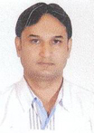
 |  |  |  |  |  | 01.08.2017 to 01.02.2021 | Lecturer
 |  |  |  |  |  | 02.02.2021 to till date | Reader
19 | Hkm. Nadeem Ahmad Khan  UNXX00217 | Abdullah Khan | 10.03.1982 | UNIVERSTY OF CALCUTA 2005 | N.A | 21.06.2010 to 22.08.2015 | Lecturer | Ibn-e-sina tibbiya college & hospital | Amraz-e-Jild wa Tazeeniyat | I S T C & H Beenapara Azamgarh | AT & POST : SHAHGANJ DIST: JAUNPUR | 8960897544 | 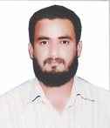
 |  |  |  |  |  | 02.08.2017 to 01.02.2021 | Lecturer
 |  |  |  |  |  | 02.02.2021 to till date | Reader
20 | Hkm. Shah Alam  UNXX00212 | Mr. Ajaz Ahmad | 20.11.1978 | BUMS AMU ALIGARH 2003 | N.A | 01.08.2012 to 08.08.2015 | Lecturer | Ibn-e-sina tibbiya college & hospital | Munafiul Aza | I S T C & H Beenapara Azamgarh | AT & PSOT MUNDIYAT DISTT: AZAMGRH | 9565441778 | 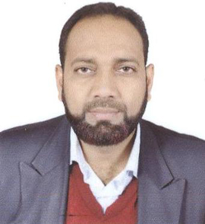
 |  |  |  |  |  | 01.09.2017 to 01.02.2021 | Lecturer
 |  |  |  |  |  | 02.02.2021 to till date | Reader
21 | Shoeb Ahmad  UNID00005 | Usman Ahmad | 20.06.1962 | B.U.M.S  AMU Aligarh 1991 | M.D (Ilmul Advia)  AMU Aligarh 1996 | 01.07.2004 to 20.06.2010 | Lecturer | Ibn-e-sina tibbiya college & hospital | Ilmul Advia | I S T C & H Beenapara Azamgarh | Vill: Teunga Post: Phoolpur Distt: Azamgarh | 9919889655 | 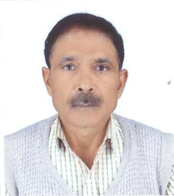
 |  |  |  |  |  | 21.06.2010 to 31.05.2023 | Reader
 |  |  |  |  |  | 01.11.2024 to till date | Reader
Cont on page 4
(4)

S.No | Name of the Teacher and Teacher code | Father’s Name | Date of Birth | UG Qualifation (University & Year) | PG Qualifation (University & Year) | Date wise detals of Experience in chronological order (1* appointment to till date |  |  |  | Local Residential Address | Permanent Address | Telephone No. & Mobile No. | Photograph
 |  |  |  |  |  | Duration | Designation | Name of the College | Department (Subject)
22 | hkm zafar javed khan  UNID00002 | javed ahmad khan | 04.06.1985 | B.U.M.S AMU Aligarh 2011 | m.d (ilmul advia)  AMU Aligarh 2017 | 05/11/2019 to till date | Lecturer | Ibn-e-sina tibbiya college & hospital | Ilmul Advia | I S T C & H Beenapara Azamgarh | Vill & Post: Mohammadpur Distt: azamgarh | 8791655865 | 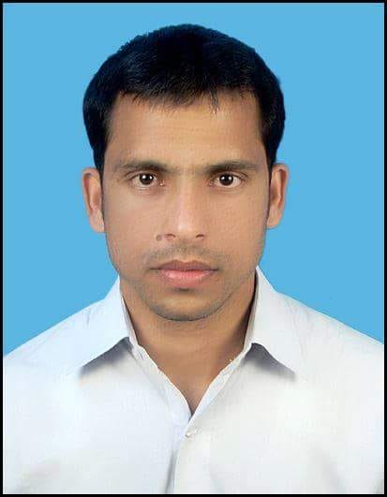
 |  |  |  |  |  | 09.11.2024 to till date | Reader
23 | dr. shoeb raza ansari  UNXX00264 | abdul subhan | 09.02.1975 | B.U.M.S  B.R Ambedkar University Bihar 1999 | N.a | 16.11.2023 | Reader | Ibn-e-sina tibbiya college & hospital | Ilmul Jarahat | I S T C & H Beenapara Azamgarh | Mohalla haidrabad mubarkhpur azamgarh | 6392629355 | 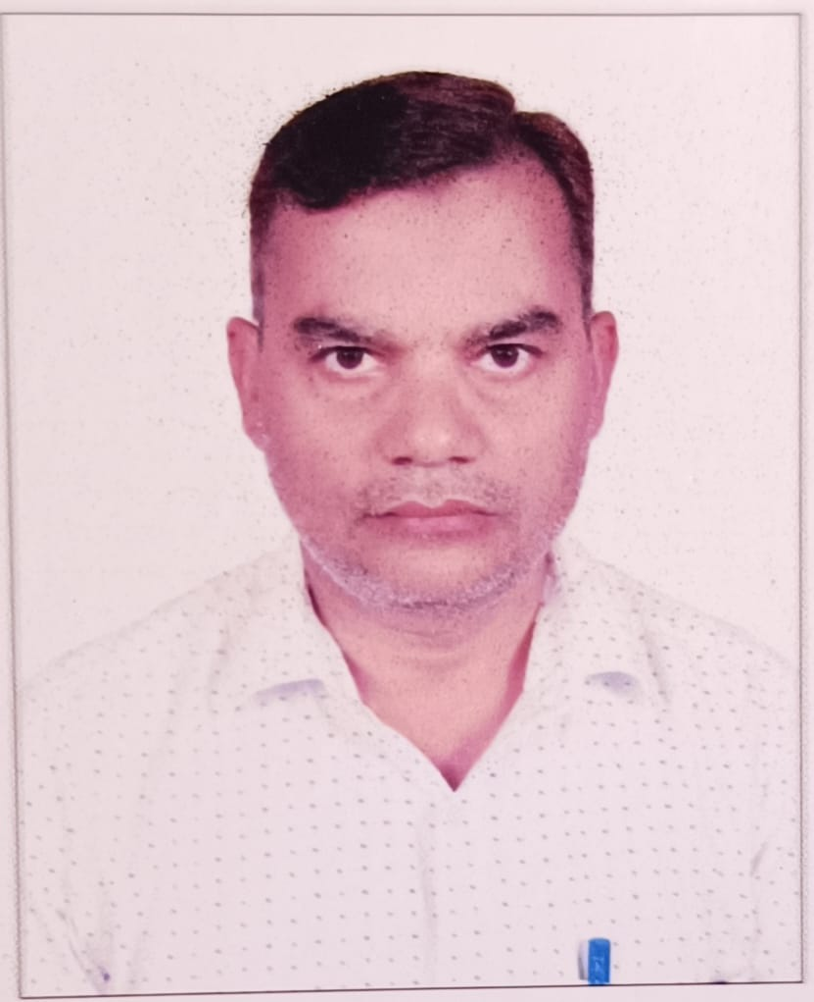
24 | hkm. mirza faiz beg  unkl00066 | mirza irfan beg | 01.02.1989 | B.U.M.S JAMIA HAMDARD 2013 | M.d (kulliyuat)  R G U H S bANGALOR  2019 | 02.01.2020 To 04.04.2022 | Lecturer | Ibn-e-sina tibbiya college & hospital | Munafiul Aza | I S T C & H Beenapara Azamgarh | Vill: M Patti Post: Semari Distt: Azamgarh | 9958368858 | 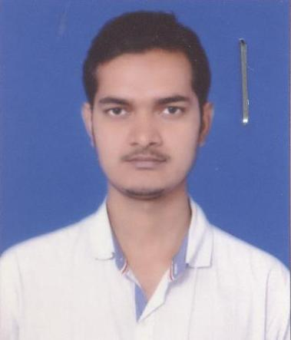
 |  |  |  |  |  | 05.04.2022 to till date | Lecturer | Ibn-e-sina tibbiya college & hospital | Kulliyat
25 | hkm. mirza BELAL BEG  UNID00168 | mirza SULTAN BEG | 05.09.1989 | B.U.M.S AMU Aligarh 2015 | M.d (ILMUL ADVIA)  K N R U H S TELANGANA  2020 | 10.12.2020 | Lecturer | Ibn-e-sina tibbiya college & hospital | Ilmul Sadila | I S T C & H Beenapara Azamgarh | Vill: Abdiha Post: Beenapara Distt: Azamgarh | 7417840003 | 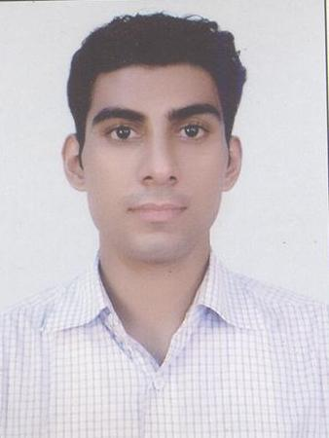
26 | tabiba habiba suhail  UNNQ00114 | auhail ahmad | 15.07.1991 | B.U.M.S AMU Aligarh 2015 | M.s  (il qabalat wa a niswan)  R G U H S bANGALOR  2020 | 10.12.2020 | Lecturer | Ibn-e-sina tibbiya college & hospital | Ilmul Atfal | I S T C & H Beenapara Azamgarh | Vill: Abdiha Post: Beenapara Distt: Azamgarh | 8272876066 | 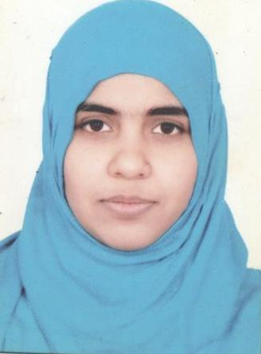
27. | hkm mohd rashid  UNIb00017 | zainul abdin | 29.08.1987 | B.U.M.S AMU Aligarh 2015 | M.d  (ilah bit tadbeer)  R G U H S bANGALOR  2020 | 10.12.2020 | Lecturer | Ibn-e-sina tibbiya college & hospital | Ilaj Bit Tadbeer | I S T C & H Beenapara Azamgarh | Vill: Bholepur Post: Hanswar Distt: Ambedkar Nagar | 7217547126 | 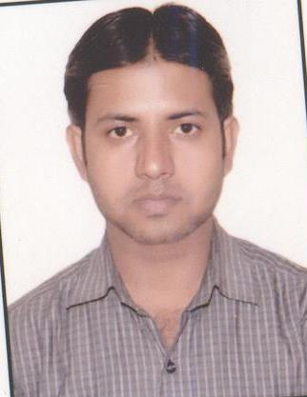
28 | Tabiba Nazreen Fatma  UNMJ00351 | Mohd Ilyas | 02.06.1993 | B.U.M.S JAMIA HAMDARD 2015 | M.d  (Moalijat)  R G U H S bANGALOR  2020 | 11.01.2021 | Lecturer | Ibn-e-sina tibbiya college & hospita | Moalijat | I S T C & H Beenapara Azamgarh | 15/116 Paltan Bazar Distt: Pratapgarh | 9873772366 | 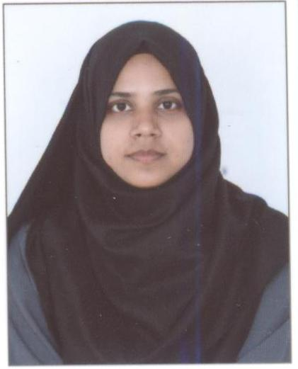
Cont on page 5

(5)

S.No | Name of the Teacher and Teacher code | Father’s Name | Date of Birth | UG Qualifation (University & Year) | PG Qualifation (University & Year) | Date wise detals of Experience in chronological order (1* appointment to till date |  |  |  | Local Residential Address | Permanent Address | Telephone No. & Mobile No. | Photograph
 |  |  |  |  |  | Duration | Designation | Name of the College | Department (Subject)
29 | Dr. nadir shahzad UNID00203 | ansar ahmad | 03.04.1986 | B.U.M.S JAMIA HAMDARD 2009 | M.d  (ilmul sadila)  R G U H S bANGALOR  2016 | 28.03.2022 | Lecturer | Ibn-e-sina tibbiya college & hospital | Ilmul Saidla | I S T C & H Beenapara Azamgarh | Vill: Ibrahimpur Post: devkali Azamgarh | 8050245210 | 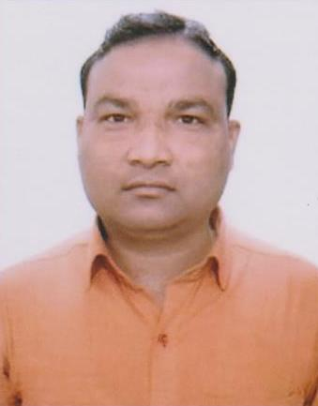
30 | Dr. nazneen arshi  UNMJ00436 | abdul udood | 07.06.1989 | B.U.M.S AMU Aligarh 2017 | m.d (Moalijat)  AMU Aligarh 2021 | 11.11.2023 | Lecturer | Ibn-e-sina tibbiya college & hospital | Moalijat | I S T C & H Beenapara Azamgarh | sakrawal west tanda ambedkar nagar | 8937085851 | 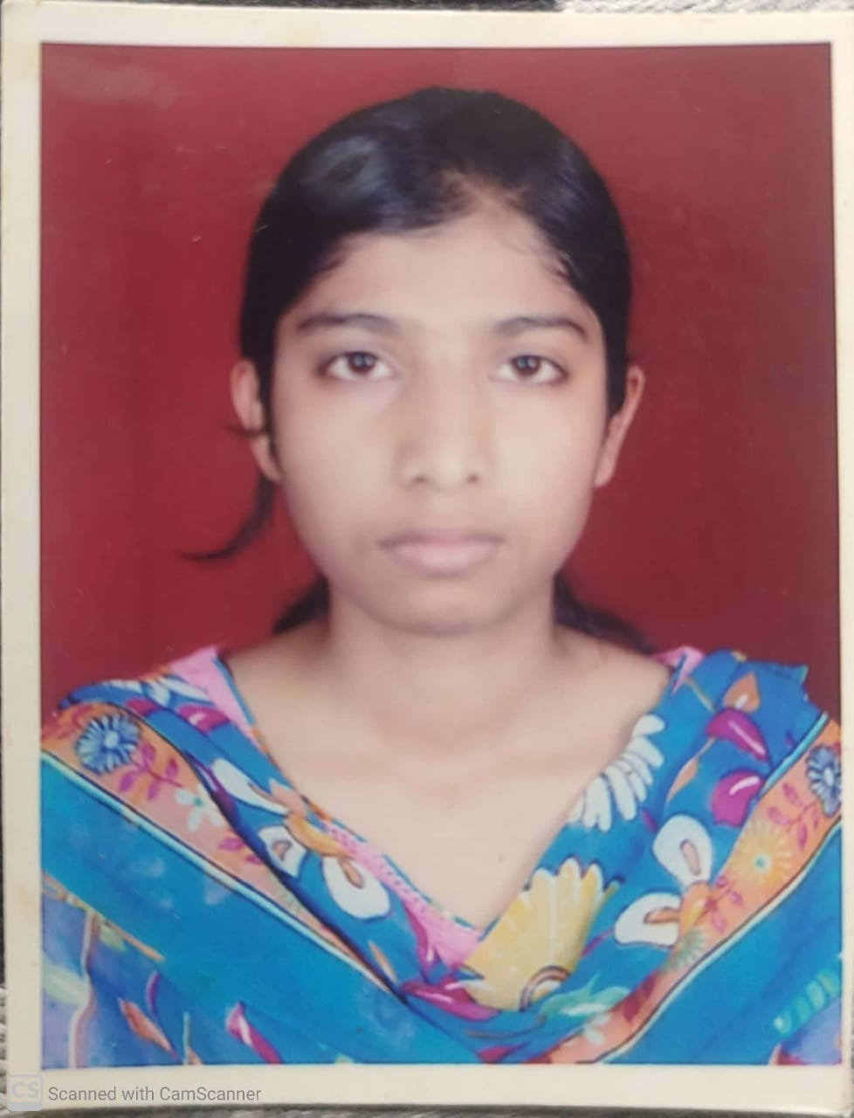
31 | DR. HARISH AFZAL | AFZAL AHMAD | 25.04.1991 | B.U.M.S AMU Aligarh 2019 | m.d (Moalijat)  K N R U H S telengana 2024 | 01.01.2025 | Lecturer | Ibn-e-sina tibbiya college & hospital | Moalijat | I S T C & H Beenapara Azamgarh | Saraiyan Mubarakhpur Azamgarh | 9794513760 | 
32 | Miss. Ayesha Jafar | Jafar Taiyar Khan | 28.12.1992 | BA  VBSP UNIVERSITY JANPUR 2010 | M.A  VBSP UNIVERSITY JANPUR  2012 | 03.08.2017 | Lecturer | Ibn-e-sina tibbiya college & hospital | Kulliyat | I S T C & H Beenapara Azamgarh | MOHALLA BAZBAHADUR POST SADAR DISTT AZMAGRAH | 8299039662 | 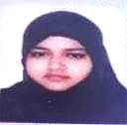
33 | Mr. MOHD TARIQUE | FIROZ AHMAD | 18.06.1995 | BA  K m c L u  lUCKNOE  2021 | M.A  K m c L u  lUCKNOE  2023 | 27.12.2024 | Lecturer | Ibn-e-sina tibbiya college & hospital | Kulliyat (Language Teacher Arabic) | I S T C & H Beenapara Azamgarh | Phariha azamgarh | 8400949555 | 